**Assignment-1:** To deploy an application in Tomcat Server using the Build Toll – Maven.

1.Tomcat server installed and running status.

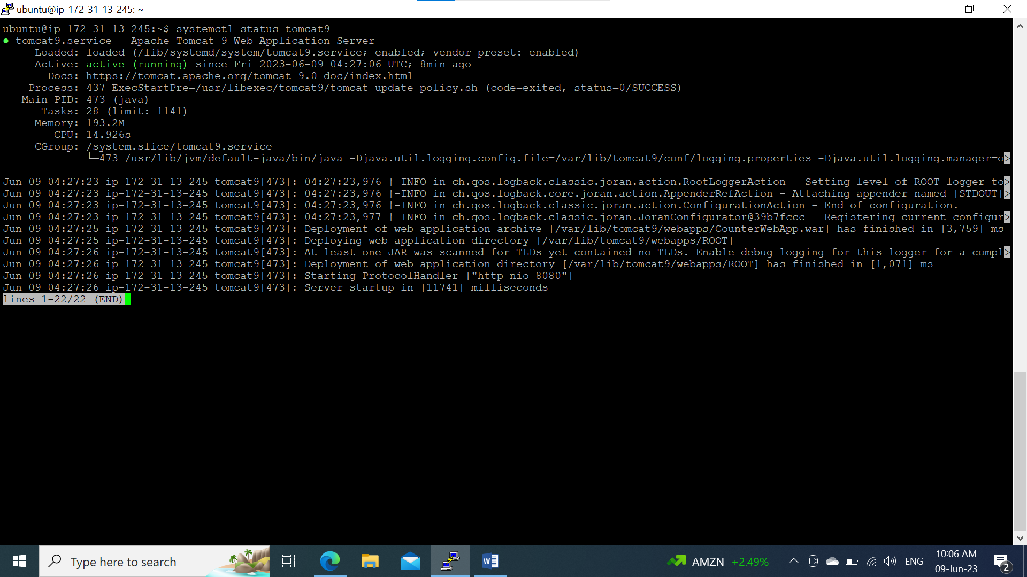

2. Build the package.

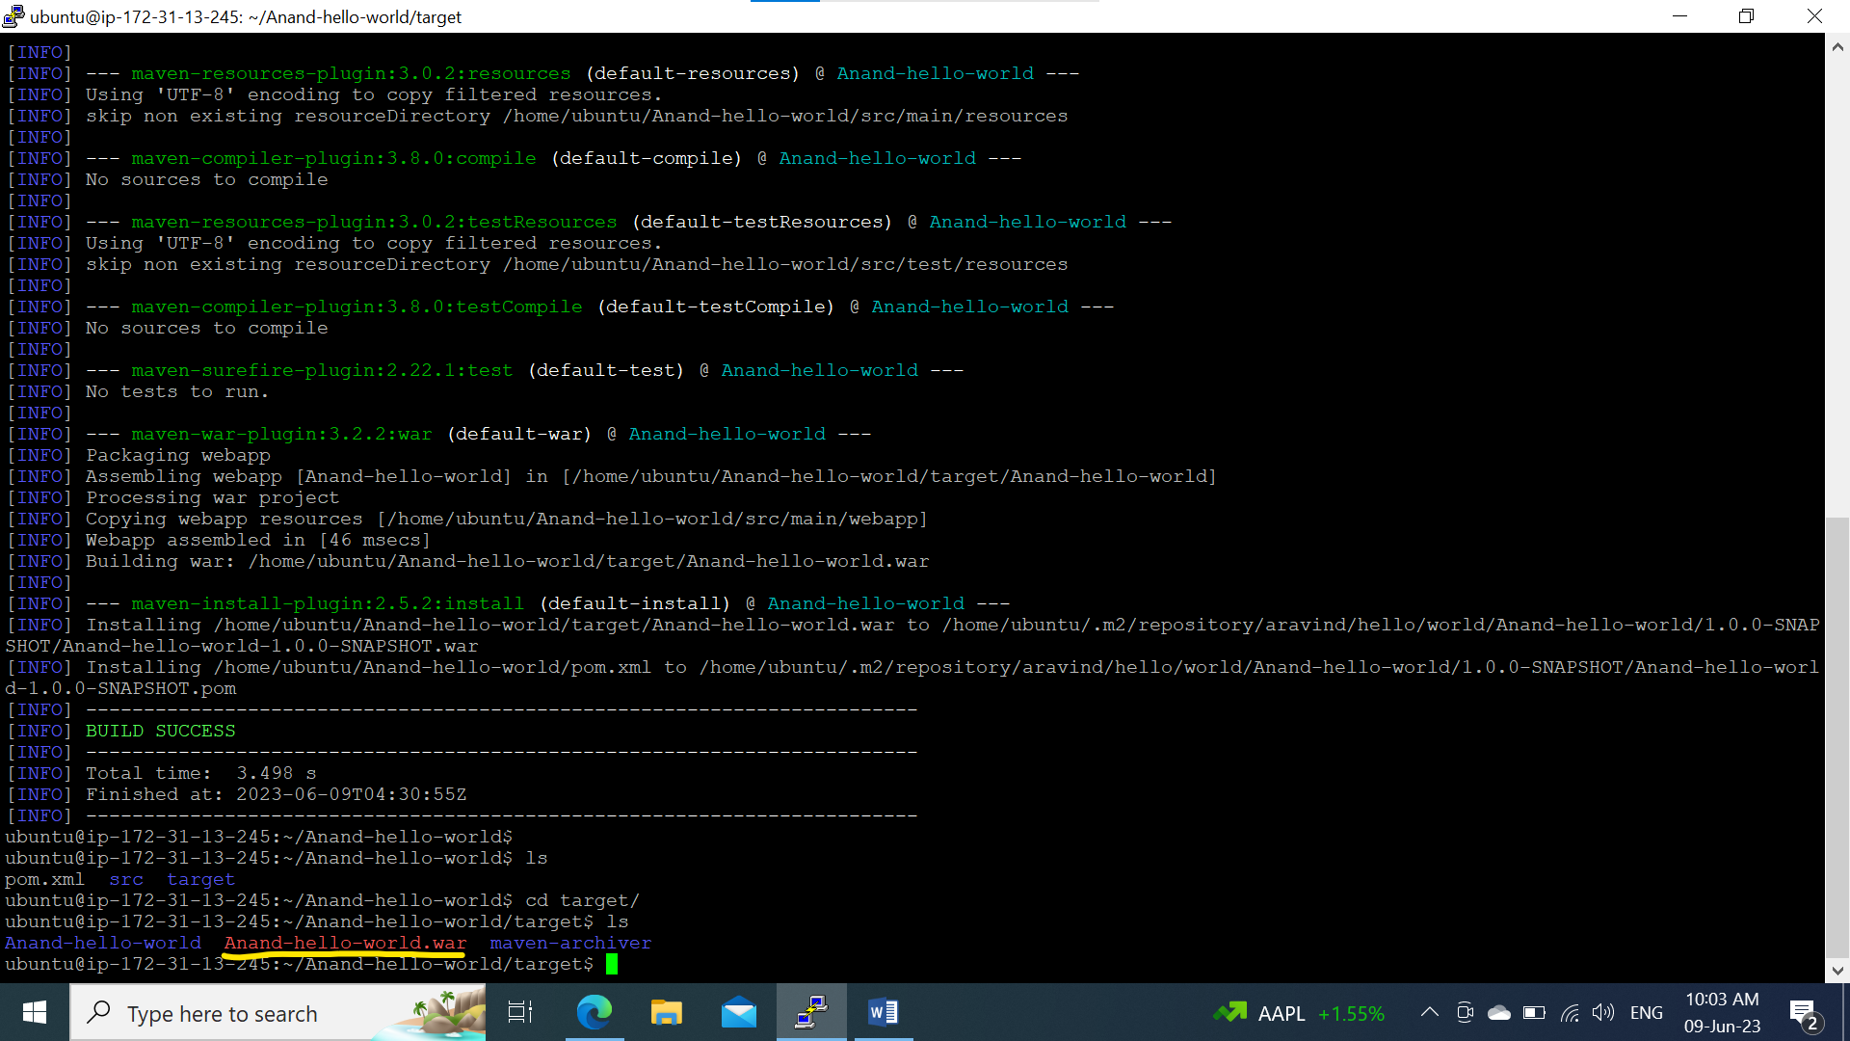

3. Deployed WAR file in Apachi Tomcat Web Server.

